A1Sauss

Classdoor

Team Overview:

Amine Kebichi: https://github.com/Aminova

Matthew Cdahl: https://github.com/matthewcdahl

Nathan Blue: https://github.com/Naflin

Spencer Rendano: https://github.com/srendano

Zander Bobronnikov: https://github.com/zanderb98

Zihang Zhou: <https://github.com/zihangzhou>

Innovative Idea:

Our project is to create a web application that provide course reviews and rating scores for courses that can help college students navigating through their college career easier and smarter. It will have some similar features as we can see from *glassdoor* and *ratemyprofessor*, etc. It would offer students an unique view for planning their academic paths.

Important Data:

Our application will use classes information from university websites, collect reviews from students, provide login function for students, allow people to give likes or dislikes of different reviews, display what people are searching for or trending search results, etc.

User Interface:

Home page: Navbar, search bar, information about the site and footer.

Class: list of classes, rating, review, etc.

Review page: rating(star), recommendation, grade, tags.

Login: register and sign in.

User Profile: username, profile image, quote.

Home page:

Class:

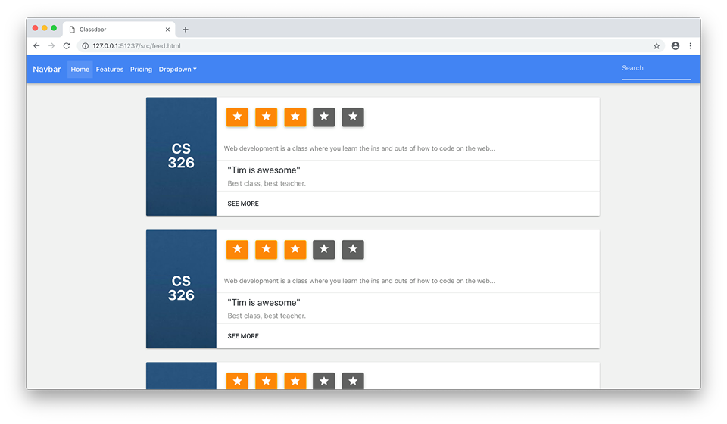

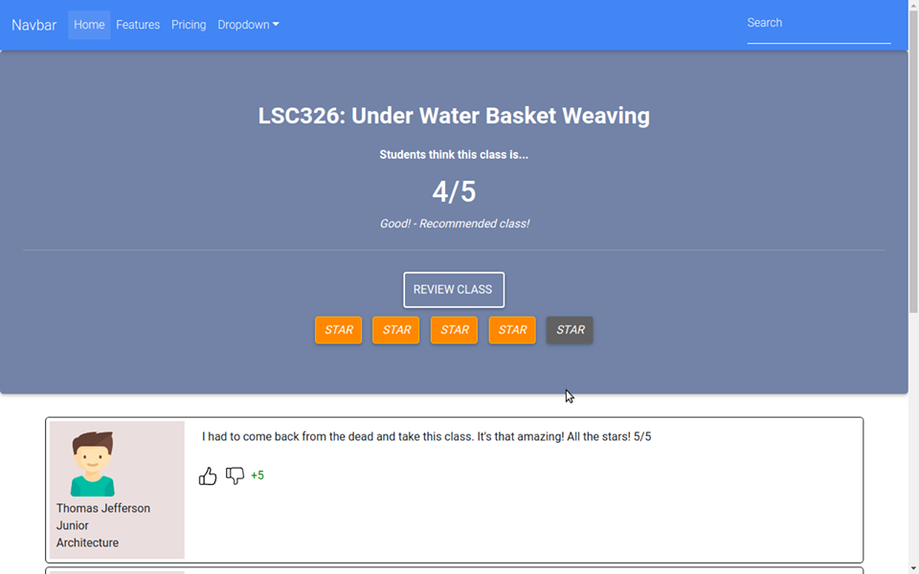

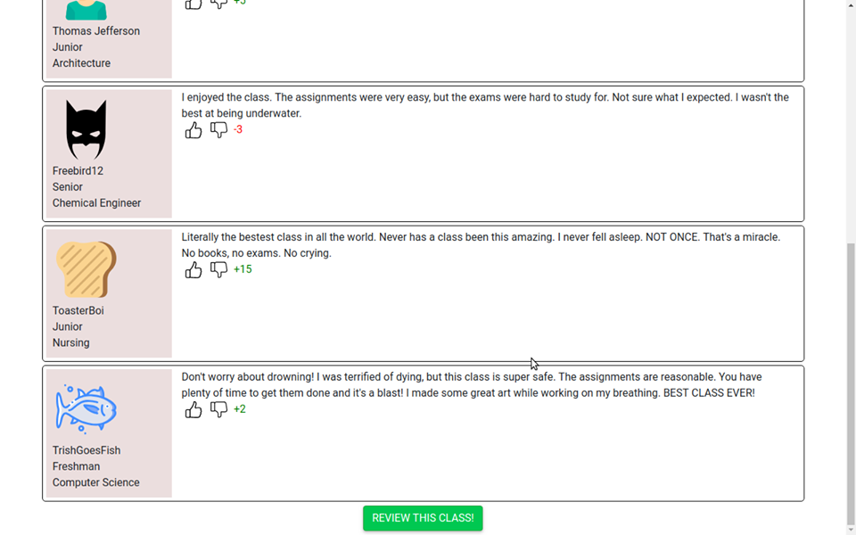

Review page:

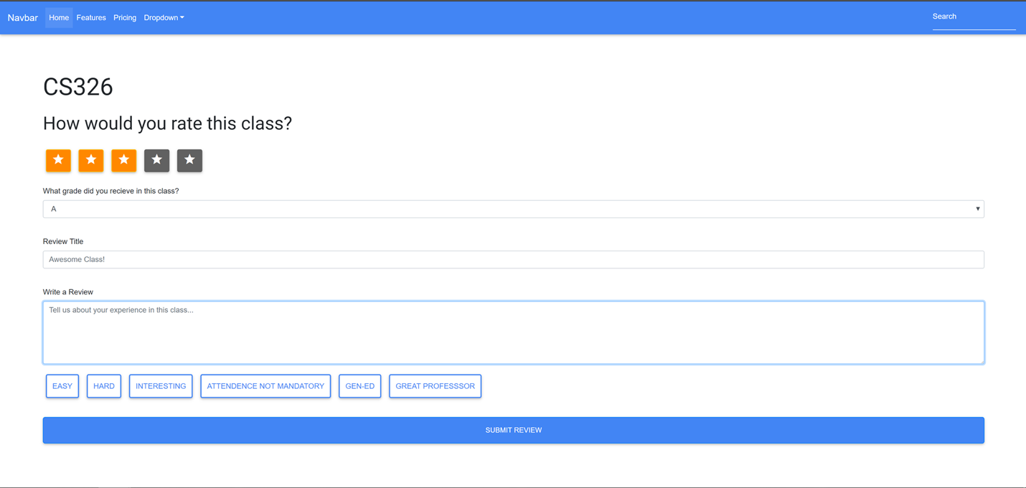

Login:

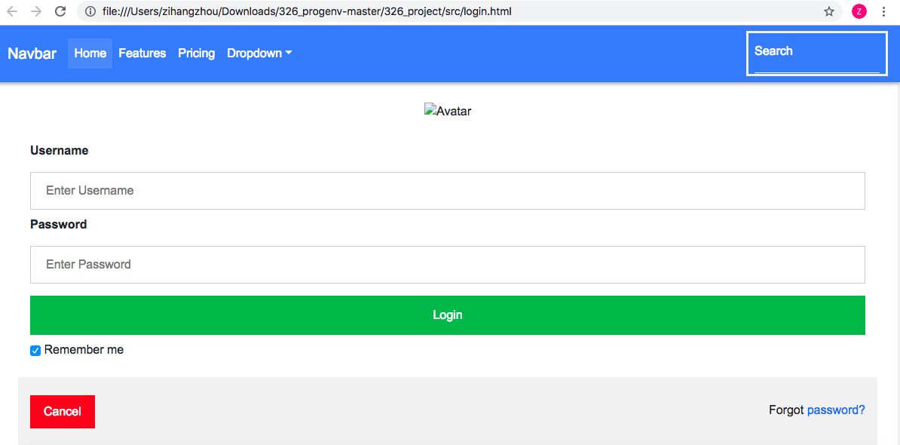

User Profile:

